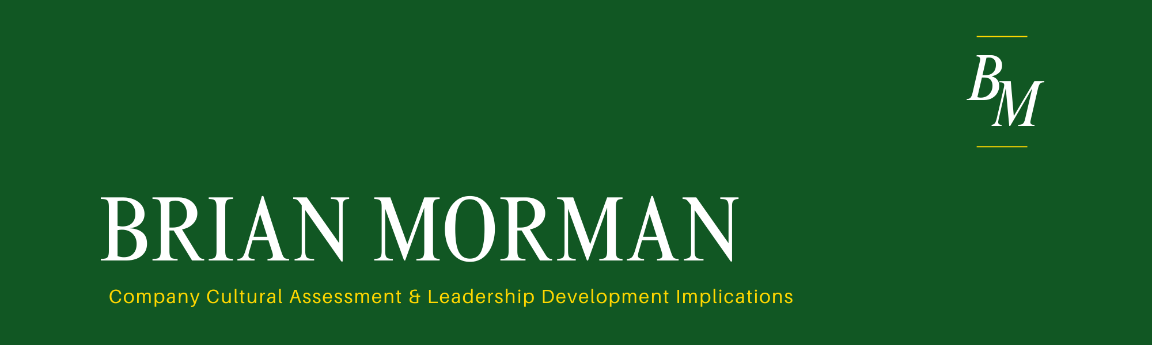


The culture of AvionX at the Boeing Company is characterized heavily by team-oriented decision making. AvionX take their role and the products they create very seriously as a rule at Boeing and apply rigorous challenges to any key decision. This kind of culture is key for a company that designs airplanes and is trusted with the lives of nearly everyone who flies. AvionX design all kinds of electronic products used in flight: flight controls, fuel sensors, and many more safety critical products. But recently the team have begun taking on some new projects with less criticality (think in-flight entertainment). The challenge AvionX is currently facing is the way decisions are made. AvionX makes decisions slowly and collaboratively with formal reviews and subject matter experts. According to an AvionX program manager, unfortunately, since AvionX competes with other commercial avionics suppliers for business, they also make products slowly and at high cost. AvionX’s slow decision-making process is driving the team to lose contracts and cost more than the competition.
The dynamic that leads to such high-cost decision making comes from a complex set of factors, but the frameworks of this course give an excellent lens through which to view those factors. First, it’s key to identify that the global team operates in a Mandate structure of hybrid teaming. The commercial products team includes US based systems engineers and program management, but the design team is housed in India. According to one US based AvionX manager, this structure is well designed in spirit. It allows economies of specialization in a highly technical industry but for reasons both good and bad AvionX is not leveraging this structure as intended. The design authority is housed in India, but its design practices and deliverables are governed by US designed gates. Asking the team in India to design product using the same processes as a US based group drives confusion and complexity into the system that generate inefficiency. For this reason, one potential solution could be to allow the design team to control its own design process with governance by local leadership and feed its review output into the program review for less potential for misunderstanding.
The framework of Erin Meyer’s cultural map is helpful in visualizing some of the cultural complexities at play.
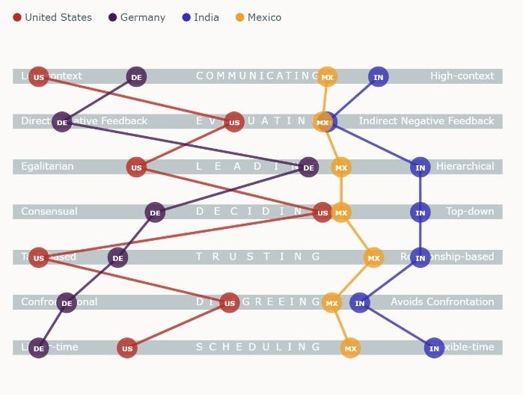
For centralization purposes, the team reuses systems and tools developed over decades of US based engineering and has not been tailored for this new global team. For example, the design review checklist has ~60 items for a particular milestone. When the Bangalore team is asked to generate a slide deck the review has hundreds of slides and lasts over two days. They are filled with deep detail and context that impresses the reviewers but takes a great deal of time to address. A Bangalore based AvionX chief engineer points out, the team in India will work long hours days, nights, and weekends to hit a milestone that the US team had viewed as flexible. Both of these create wasted work and slow progress. What makes this situation even worse is the fact that the US team is spread all across the US from St. Louis, to Dallas, to Seattle. Cultural distance and differing tightness of culture exists within even the same country-based stakeholders which can frustrate and confuse the Bangalore based designers. A potential solution to this challenge is to manage communications through an intentional chain. Requirements can flow from Seattle or Dallas into India but not from both teams. In this way, the team has fewer cultural dynamics to contend with. They can shorten the cultural distance by creating clear and intentional communication channels.
A third cultural challenge within AvionX comes from economic distance within the Boeing company’s different enterprises. This third challenge feels unique to Boeing specifically and it comes from the fact that Boeing serves two very different customers in commercial aviation and in military aviation. One is publicly funded, a public “good” that comes from the taxpayer dollar. In this space the spend is tightly tracked and efficiency is rarely a top goal of any design program. This comes from the heavy regulation involved with government funded R&D. The other side of the business operates more classically as a P&L that operates to make money. Because the goals of these organizations and the funding that drives them come from such different philosophies, the culture that surrounds them is very different as well. Team members often move from one enterprise to the other and bring their best practices with them as they go. This kind of centralization should be a good thing, but the two businesses fundamentally need to have different cultures to be successful in their own way. Because of this difference, centralization has been challenging and can be clunky. A project engineer described a process of time accounting mandated by the government called “Earned Value Management” (EVM). EVM is a way of tightly accounting for the spend of engineering hours to report on progress to the government on a public funded program. Boeing carried EVM across enterprises and began running EVM as a required process on internal programs on occasion to improve time accounting practices. What they found was rising head counts and slower progress on projects in exchange for improved hourly accounting. What works in one enterprise does not always benefit the other. A solution to this problem could be careful vetting of best practices as they cross enterprise lines by a group of business strategists who can help determine if the centralization of processes really fits with the goals and cultures of each enterprise.
In summary, AvionX faces significant challenges in its decision-making processes due to its hybrid team structure, cultural complexities, and the cultural differences between the enterprises. Each of the three actions proposed above would bring benefits to the operations of Boeing AvionX. But the most impactful action would be to allow the Bangalore design team to govern its own design processes with local leadership oversight. This approach not only addresses the inefficiencies stemming from the current governance model but also fosters a sense of ownership and accountability within the team. By streamlining decision-making and reducing confusion, the AvionX team can get the best out of the Hybrid structure and multinational team to compete and win in the avionics industry.


At the time of writing this paper, I am in a bit of a waiting period in my career which makes this the perfect time for introspection on my own leadership development. I have accepted a new role at Boeing as a manager in the phantom works organization. That job offer is contingent upon a certain contract award from the DoD to the company. In my career so far, I have been a leader only in informal ways, but my new role will have 18 direct reports with multiple engineering skillsets. Most of these reports will be early career engineers and all of them based in St. Louis. In some ways the team culture has already been set over the last year as the team has been together, but the contract award will bring new urgency and energy to the team and I will be expected to help the team turn that energy into quick progress. Over the next five years, I plan to begin a role in engineering leadership and to grow from first line manager to senior manager.
Because of the nature of the projects in Phantom Works my team will be entirely US based so geographical distance won’t be an immediate factor. The hurdles I will face will come from, joining a culture already in motion, and the process issues brought on by the economic distance between Boeing’s multiple enterprises. As I prepare to enter this new team environment, I found the concept of “Becoming Culturually Bayesian” to be particually interesting. In our qualtrics survey I was immediately stuck by how high the scores from all survey takers are in the drivers of Bayesian Perception. All survey takers believe themselves to be capable of Bayesian thought. In my experience, humans (or at least engineers) are not so easily disuaded of their opinions and throughts. What I have come to take away from this score is that we as individuals need to be especially criticial of our own beliefs. Practices like emplying devils advocacy may be helpful in pushing us off our center to ensure we are truly considering that our held opinions may be wrong. If we can remain impartial to our own biases and remain data driven and curious we can avoid falling into the trap of believing our first hypothesis is the right one or in my case as a new leader, believeing I know what kind of culture a team needs. It will be key in my new role to be curious about the ways the team works, identify strengths in the culture and weaknesses and identify how to strategicly change behaviors that don’t contribute to the goal.
The cultural intelligence survey results tell me that I have average CQ motivation, slightly above average CQ Knowledge, Below average CQ strategy and below average CQ Behavior.
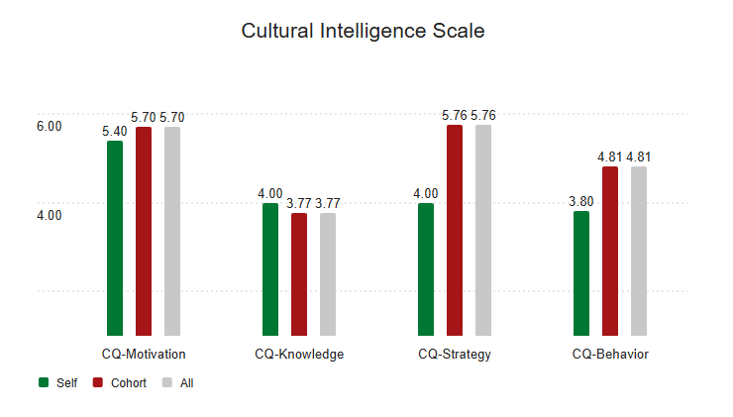
While these scores feel somewhat subjective, I think they do expose a weakness in my leadership background. I have lived in the Midwest my whole live, I am not particularly well traveled, I have worked with people from China to New Zealand, to Mexico and more but heavily via remote communications. Curiosity is a strong suit of mine, but I have not been overly focused on getting outside of my cultural comfort zone during my career. A key to my growth in cultural intelligence will be to look for opportunities to experience new cultures. I can achieve this growth in a number of ways. 1) The international residency coming up next month is a jump start. I will get outside my hotel room and explore Europe. I will look for a classmate who has more travel experience and see how they go about visiting a new city. 2) I can find cultural opportunities within Boeing. Boeing has employee resource groups, but I have yet to join them. At GE I attended multiple events with our LatinX ERG where I was the only non-Spanish speaker in the room. I will try to replicate that within Boeing or look for connections in the city greater. In finding opportunities to get uncomfortable, I can stretch my cultural intelligence and cultivate the curiosity that makes Bayesian behavior possible.
The final class framework I want to touch on is the cultural mapping of myself vs my company. 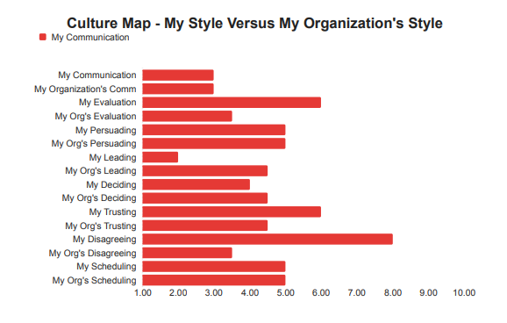
In looking at my results, a few things jump off the page. First, I am not one for direct disagreement, my company is. I am getting more used to confrontation and disagreements. In my new role these interactions will be unavoidable as a leader of people, and I am looking forward to facing that growth opportunity to face disagreement and become more comfortable with that kind of exchange. Second, I have a propensity for indirect negative feedback. In the past, I have not been directly responsible for the performance of any engineer. In my new role, I will need to be honest in my assessments and provide negative feedback where it is warranted. To be flexible and meet the needs of my team in both these spaces I will need to be organized in my assessments of teammates and prepared to bring facts to these conversations that can easily become emotional. By being aware of these weaknesses, I feel that I am ready for a challenge and change in my career path that will serve me well in years to come.



